Day33&34 - Task16 - AWS ELB(Load Balancing)

1. Configure Classic Load balancer

The Classic Load Balancer (CLB) provides basic load balancing across multiple Amazon EC2 instances. It is suitable for applications that were built within the EC2-Classic network.

Step 1: Create Classic Load Balancer
- Open the EC2 Management Console, navigate to "Load Balancers" under the "Load Balancing" section, and click "Create Load Balancer".
- Select "Classic Load Balancer" and provide a name (e.g., classic-lb-demo).
- Select the appropriate VPC and choose the specific subnets where the load balancer should be available.
- Define the Listener Configuration: Set the Load Balancer Protocol to HTTP on Port 80 and the Instance Protocol to HTTP on Port 80.
- In the "Assign Security Groups" tab, select or create a security group that allows inbound traffic on port 80 from 0.0.0.0/0.
- Configure Health Check: Set the Ping Protocol to HTTP, Port to 80, and Ping Path to "/index.html".
- Register the target EC2 instances and complete the creation process.
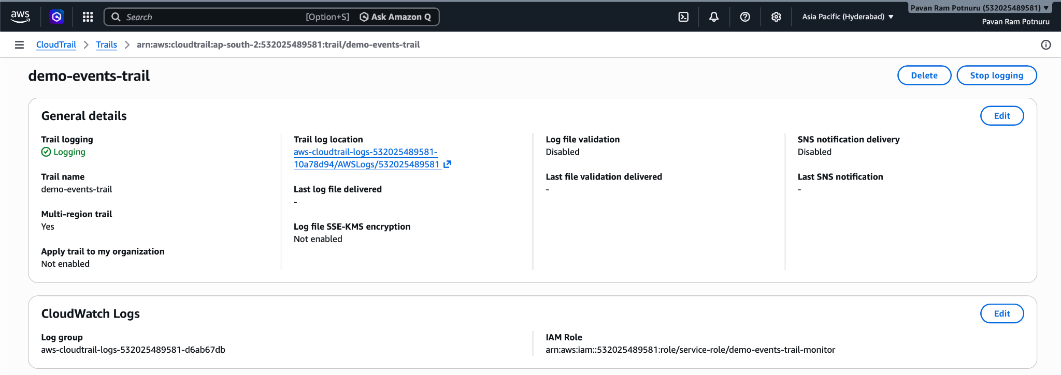

2. Configure Application Load balancer

Application Load Balancer (ALB) functions at the application layer (Layer 7) and supports path-based and host-based routing to different target groups, such as Nginx or Apache servers.

Step 1: Setup Application Load Balancer
- Navigate to "Load Balancers" > "Create Load Balancer" and select "Application Load Balancer" (ALB).
- Name the ALB "demo-app-lb", select the "Internet-facing" scheme, and choose the VPC and at least two Availability Zones/Subnets.
- Configure a Security Group that permits HTTP (Port 80) access from the internet.
- Configure Routing: Create a new Target Group named "tg-app-servers" using "Instances" as the target type.
- Set up the Health Check for the target group: Select "HTTP" as the protocol and "/" as the health check path.
- Register your Nginx or Apache EC2 instances as targets within this group and finalize the ALB configuration.
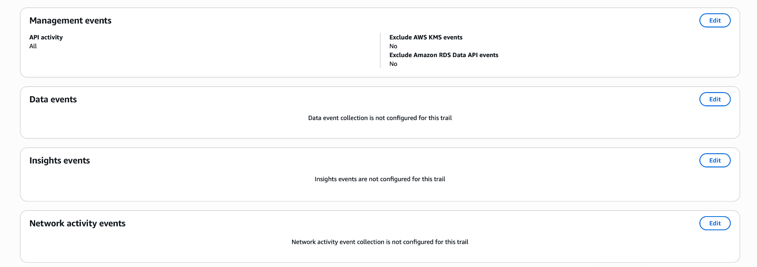
Field | Value
Load Balancer Name | demo-app-lb
Target Group | tg-app-servers
Protocol | HTTP
Port | 80

3. Configure Network Load balancer

Network Load Balancer (NLB) operates at the connection level (Layer 4) and is capable of handling millions of requests per second while maintaining ultra-low latencies.

Step 1: Create Network Load Balancer
- Select "Network Load Balancer" from the creation wizard and name it "demo-network-lb".
- Select the target VPC and assign the subnets for the load balancer.
- Set the Listener to listen on TCP protocol on Port 80.
- Configure a Target Group selecting either "Instances" or "IP addresses" as the target type, then register the backend targets.
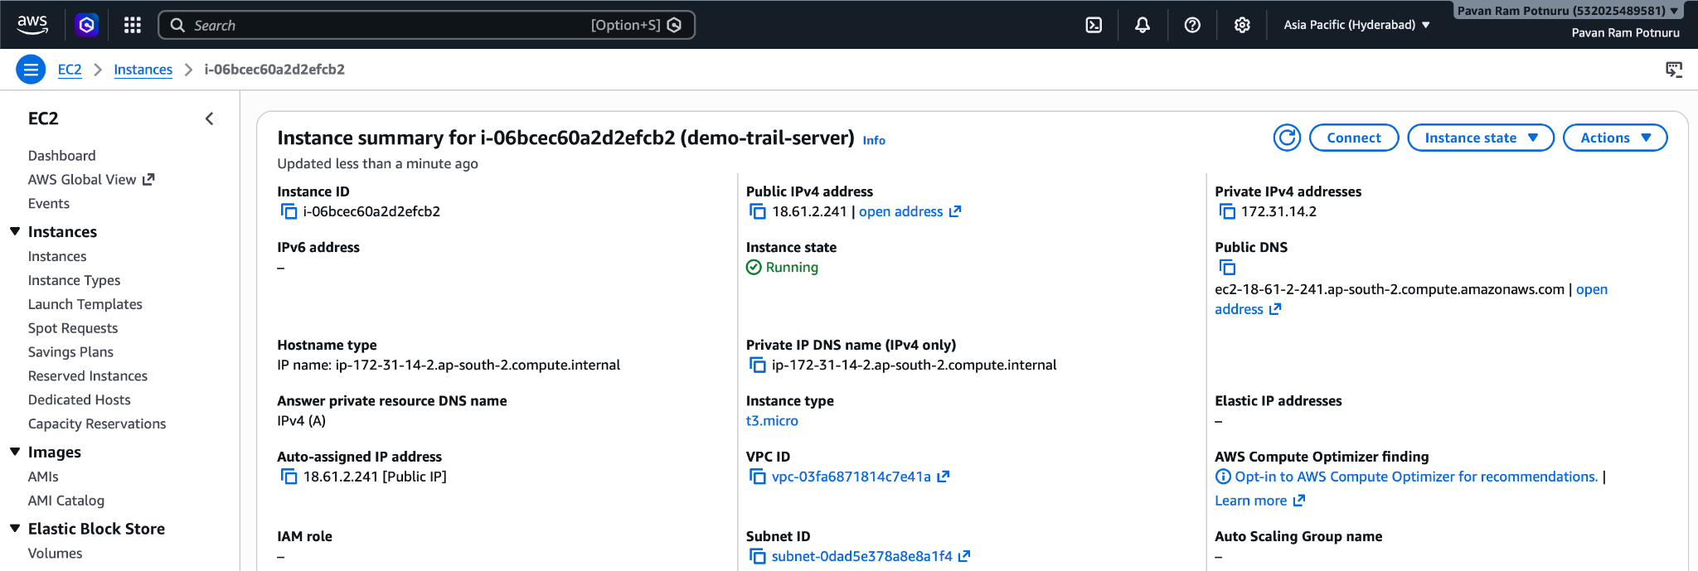

4. Attach SSL for application load balancer

Secure your application by attaching an SSL certificate to the ALB using AWS Certificate Manager (ACM).

Step 1: Request and Attach SSL Certificate
- Request a Public Certificate in AWS Certificate Manager (ACM) for your domain name (e.g., example.com).
- Choose "DNS Validation" and create the CNAME records in Route 53 to verify domain ownership.
- Once issued, navigate back to your ALB and add a new Listener for HTTPS on Port 443.
- In the listener settings, select "From ACM" and choose your validated certificate, then set the default action to forward to your target group.
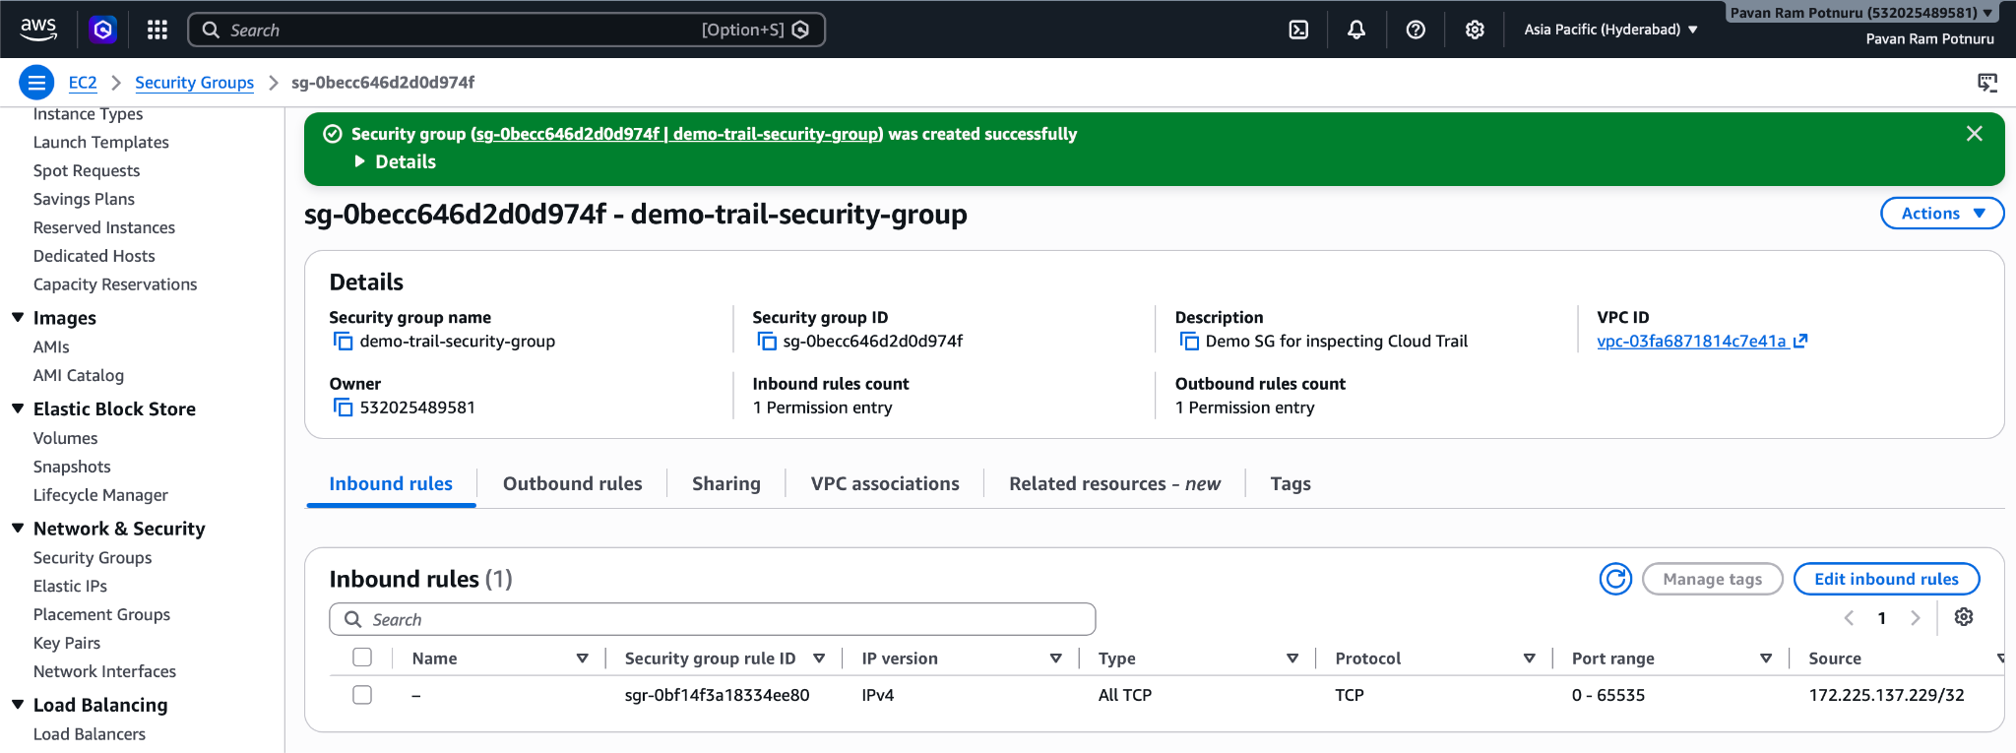

5. Map Application load balancer to R53

Use Route 53 to map a user-friendly domain name to your Load Balancer's DNS endpoint.

Step 1: Create Route 53 Alias Record
- In the Route 53 Management Console, open your Hosted Zone and click "Create Record".
- Select "A - IPv4 address" as the record type.
- Enable the "Alias" toggle.
- In the "Route traffic to" dropdown, select "Alias to Application and Classic Load Balancer".
- Specify the AWS region and then choose the DNS name of the ALB created earlier from the list.
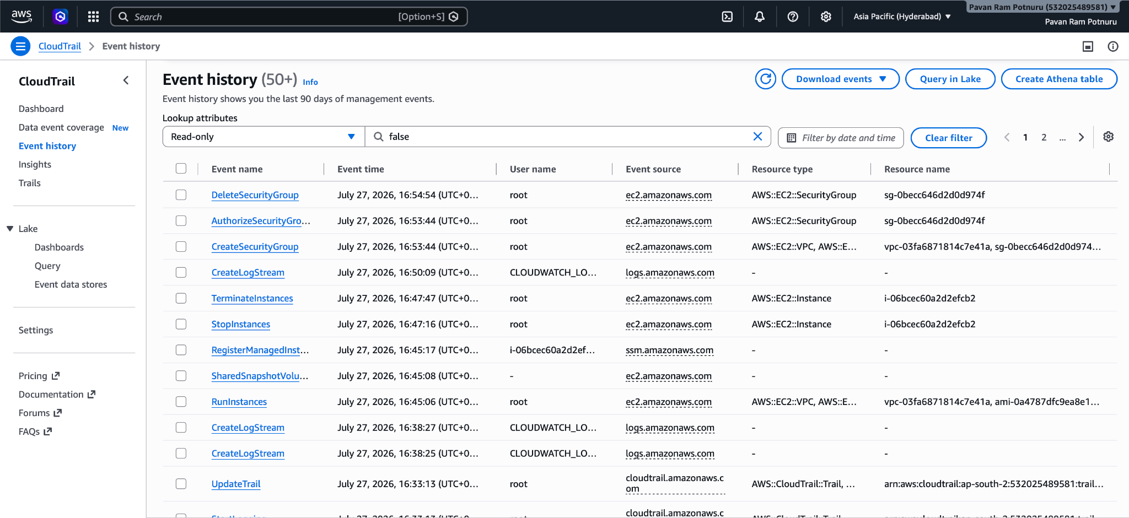

6. Push the application load balancer logs to S3

Configure your ALB to store access logs in an Amazon S3 bucket for auditing and traffic analysis.

Step 1: Enable Access Logs
- Create an Amazon S3 bucket (e.g., "my-alb-access-logs-pavan") and apply a bucket policy that grants the Elastic Load Balancing service principal permission to write logs to the bucket.
- Navigate to the ALB in the EC2 Console, select the "Attributes" tab, and click "Edit".
- Check the "Access logs" box to enable them.
- Enter the S3 URI or the bucket name in the S3 location field and save the changes.
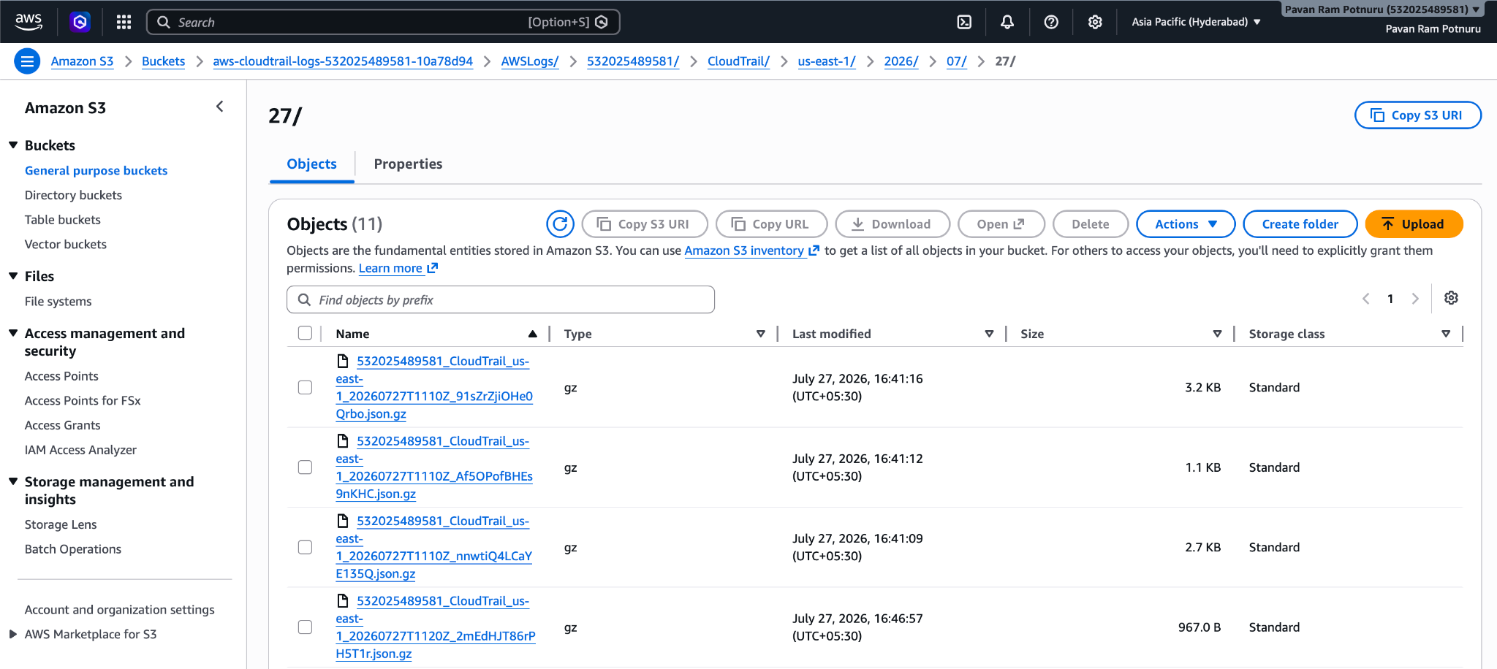

This setup ensures high availability and security for your applications hosted on EC2.

